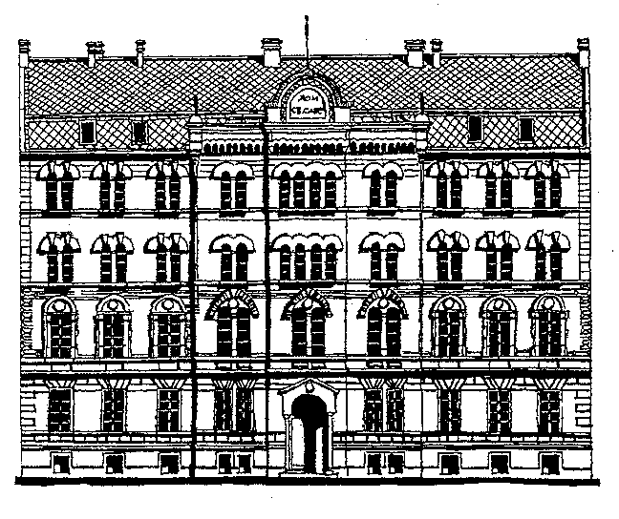 | DOCTORAL STUDIES
REQUEST FOR APPOINTMENT OF COMMISSION TO REVIEW AND EVALUATION OF DOCTORAL THESIS SCIENTIFIC-TEACHING COUNCIL OF THE FACULTY |  |  | School year  20___/20___
Student data
Name  Surname  Index number |  | Scientific field of doctoral thesis
Mentor on doctoral dissertation data
Name  Surname |  | Scientific field  Title  Institution
Doctoral dissertation title
Title

approved at the meeting Teaching and Research Council of the (date of the meeting at which the Commission adopted a report on the thesis)

Scientific works
Scientific works from doctoral dissertation of the candidate as lead author and not used in other dissertations (at least two):

The proposal members of the commission for review and evaluation
No. | Name and surname | Institution | Signature

Commission shall consist of at least three members of who at least one (but not more than half the members) is not employed at the Faculty of Physics.
Agreed coordinator scientific field of doctoral study:

Name and surname |  | Signature
Date |  | Student signature

